Ideation Phase
Brainstorm & Idea Prioritization Template

Date | 10 February 2026
Team ID | LTVIP2026TMIDS67435
Project Name | Weather-Based Prediction Of Wind Turbine Energy Output:  A Next-Generation Approach To Renewable Energy Management
Maximum Marks | 4 Marks

🧠 – Ideation phase

Step 1: Define the Goal
How might we develop an intelligent weather-based predictive system that accurately forecasts wind turbine energy output to optimize renewable energy generation, improve grid stability, and support sustainable power management?
Step-1: Team Gathering, Collaboration and Select the Problem Statement
Identified Problem Statement:
Wind energy generation is highly dependent on fluctuating weather conditions such as wind speed, temperature, air density, humidity, and atmospheric pressure. Inaccurate prediction of wind turbine output leads to:
- Grid instability
- Energy wastage
- Inefficient energy storage utilization
- Financial losses for energy providers
Selected Problem:
Develop an AI-driven predictive model that accurately estimates wind turbine energy output using real-time and historical weather data.

Step-2: Prepare for Brainstorm
Participants:
- Data Scientists, AI/ML Developers, Renewable Energy Experts, Software Developers, System Analysts, Grid Management Professionals
Duration: 30–60 minutes
Tools: Whiteboard / Smartboard, Sticky Notes, Miro / FigJam ,Python & Jupyter Notebook,
Weather Dataset (NOAA / Local Meteorological Data)

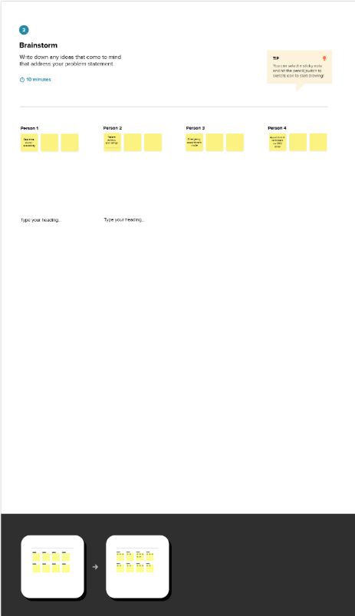

Step 3: Brainstorming Session

Idea ID | Idea Description | Problem Solved | Feasibility (Low/Med/High) | Initial Impact (Low/Med/High) | Notes
1 | Machine Learning model using Random Forest | Improves prediction accuracy | High | High | Requires labeled historical dataset
2 | Deep Learning (LSTM) for time-series forecasting | Handles temporal weather patterns | Medium | High | Needs large dataset
3 | Real-time weather API integration | Live output forecasting | High | High | Needs API subscription
4 | Hybrid ML + Physical Turbine Model | Better reliability | Medium | High | Complex integration
5 | Dashboard for energy prediction visualization | Easy monitoring | High | Medium | Can use Flask/React
6 | Automated grid load balancing alerts | Prevents overload | Medium | High | Needs grid integration

Step 4: Group and Refine Ideas
Cluster similar ideas under key themes such as:
🔹 Data & Prediction Models : Random Forest Model, LSTM Time Series Model ,Hybrid ML +
Physical Model.
🔹 Real-Time Integration : Weather API Integration, Live Forecast Monitoring
🔹 Visualization & Monitoring : Prediction Dashboard, Energy Output Analytics
🔹 Smart Grid Optimization : Automated Load Balancing Alerts, Storage Optimization Suggestions

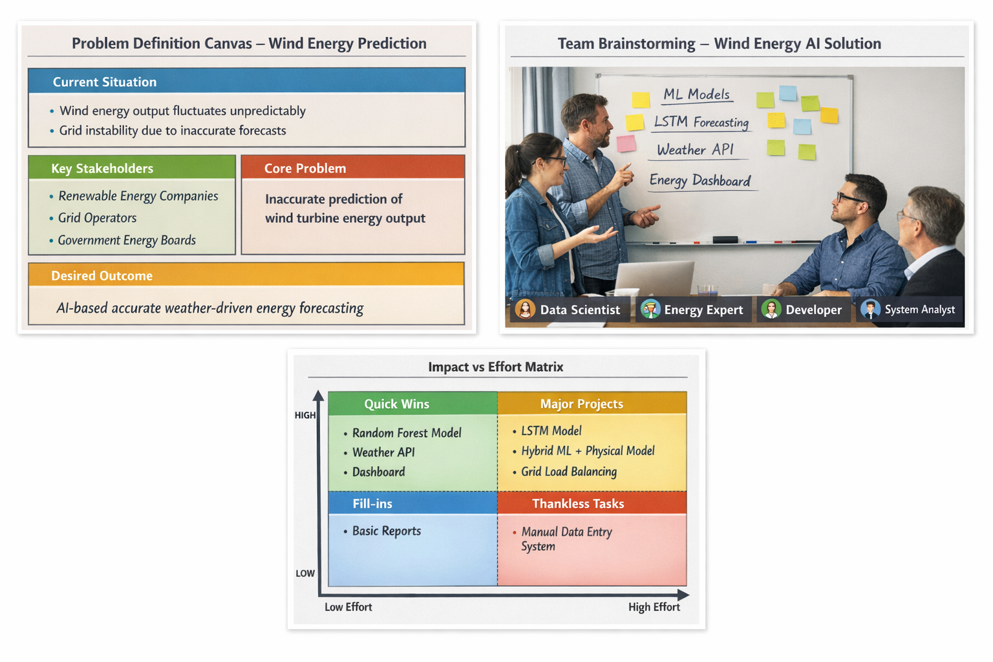

Step-3: Idea Prioritization
Prioritization Matrix (Graphical Tool)
Map ideas based on Impact vs Effort.
Quick Wins (High Impact, Low Effort) – Prioritize First
- Random Forest Prediction Model
- Dashboard Visualization
- Weather API Integration
🚀 Major Projects (High Impact, High Effort) – Strategic Planning
- LSTM Deep Learning Model
- Hybrid ML + Physical Model
- Automated Grid Load Balancing
🟡 Fill-ins (Low Impact, Low Effort) – Do If Resources Allow
- Basic Reporting Module
- Historical Data Comparison Charts
❌ Thankless Tasks (Low Impact, High Effort) – Avoid
- Overly Complex Physical Simulation without Data Support
- Manual Weather Data Entry System

Quadrants:
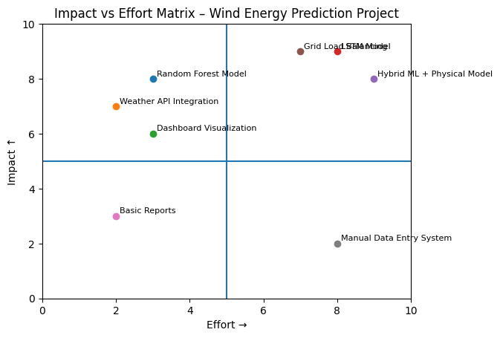
Here’s a visual Impact vs Effort Matrix with sample “Weather-Based Prediction Of Wind Turbine Energy Output” ideas plotted.
- High Impact + High Effort: LSTM & Hybrid AI Models → Long-term strategic innovation.
- High Impact + Low Effort: Random Forest Model + Dashboard → Immediate implementation.
- Low Impact Areas: Non-automated manual processes.

